**PRACTICAL-2**

**AIM**

Understanding of basic CloudSim Examples.

(1) Write a program in cloudsim using NetBeans IDE to create a datacenter with one host and run four cloudlet on it.

(2) Write a program in cloudsim using NetBeans IDE to create a datacenter with three hosts and run three cloudlets on it.

**IMPLEMENTATION**

**Code for Datacenter with 1 host and 4 cloudlets:**

import java.text.DecimalFormat;

import java.util.ArrayList;

import java.util.Calendar;

import java.util.LinkedList;

import java.util.List;

import org.cloudbus.cloudsim.Cloudlet;

import org.cloudbus.cloudsim.CloudletSchedulerTimeShared;

import org.cloudbus.cloudsim.Datacenter;

import org.cloudbus.cloudsim.DatacenterBroker;

import org.cloudbus.cloudsim.DatacenterCharacteristics;

import org.cloudbus.cloudsim.Host;

import org.cloudbus.cloudsim.Log;

import org.cloudbus.cloudsim.Pe;

import org.cloudbus.cloudsim.Storage;

import org.cloudbus.cloudsim.UtilizationModel;

import org.cloudbus.cloudsim.UtilizationModelFull;

import org.cloudbus.cloudsim.Vm;

import org.cloudbus.cloudsim.VmAllocationPolicySimple;

import org.cloudbus.cloudsim.VmSchedulerTimeShared;

import org.cloudbus.cloudsim.core.CloudSim;

import org.cloudbus.cloudsim.provisioners.BwProvisionerSimple;

import org.cloudbus.cloudsim.provisioners.PeProvisionerSimple;

import org.cloudbus.cloudsim.provisioners.RamProvisionerSimple;

public class Prac2_A {

/**

* @param args the command line arguments

*/

private static List<Cloudlet> cloudletList;

private static List<Vm> vmlist;

public static void main(String[] args)

{

Log.printLine("Starting Cloudsim ...");

try

{

int num_user = 1;

Calendar calendar = Calendar.getInstance();

boolean trace_flag = false;

CloudSim.init(num_user, calendar, trace_flag);

Datacenter datacenter0 = createDatacenter("Datacenter_0");

DatacenterBroker broker = createBroker("Broker");

int brokerId = broker.getId();

vmlist = new ArrayList<Vm>();

int vmid = 0;

int mips = 1000;

long size = 10000;

int ram = 512;

long bw = 1000;

int pesNumber = 1;

String vmm = "Xen";

Vm vm = new Vm(vmid, brokerId, mips, pesNumber, ram, bw, size, vmm, new CloudletSchedulerTimeShared());

vmlist.add(vm);

broker.submitVmList(vmlist);

cloudletList = new ArrayList<Cloudlet>();

int id = 0;

long length = 400000;

long fileSize = 300;

long outputSize = 300;

UtilizationModel utilizationModel = new UtilizationModelFull();

Cloudlet cloudlet0 = new Cloudlet(id++, length, pesNumber, fileSize, outputSize, utilizationModel, utilizationModel, utilizationModel);

cloudlet0.setUserId(brokerId);

cloudlet0.setVmId(vmid);

cloudletList.add(cloudlet0);

Cloudlet cloudlet1 = new Cloudlet(id++, length, pesNumber, fileSize, outputSize, utilizationModel, utilizationModel, utilizationModel);

cloudlet1.setUserId(brokerId);

cloudlet1.setVmId(vmid);

cloudletList.add(cloudlet1);

Cloudlet cloudlet2 = new Cloudlet(id++, length, pesNumber, fileSize, outputSize, utilizationModel, utilizationModel, utilizationModel);

cloudlet2.setUserId(brokerId);

cloudlet2.setVmId(vmid);

cloudletList.add(cloudlet2);

Cloudlet cloudlet3 = new Cloudlet(id++, length, pesNumber, fileSize, outputSize, utilizationModel, utilizationModel, utilizationModel);

cloudlet3.setUserId(brokerId);

cloudlet3.setVmId(vmid);

cloudletList.add(cloudlet3);

broker.submitCloudletList(cloudletList);

CloudSim.startSimulation();

CloudSim.stopSimulation();

List<Cloudlet> newList = broker.getCloudletReceivedList();

printCloudletList(newList);

Log.printLine("CloudSim example finished!");

}

catch(Exception ex)

{

ex.printStackTrace();

Log.printLine("Unwanted error occured");

}

}

public static Datacenter createDatacenter(String name)

{

List<Host> hostList = new ArrayList<Host>();

List<Pe> peList = new ArrayList<Pe>();

int mips = 1000;

peList.add(new Pe(0, new PeProvisionerSimple(mips)));

int hostId = 0;

int ram = 2048;

long storage = 1000000;

int bw = 10000;

hostList.add(new Host(hostId, new RamProvisionerSimple(ram), new BwProvisionerSimple(bw), storage, peList, new VmSchedulerTimeShared(peList)));

String arch = "x86";

String os = "Linux";

String vmm = "Xen";

double time_zone = 10.0;

double cost = 3.0;

double costPerMem = 0.05;

double costPerStorage = 0.001;

double costPerBw = 0.0;

LinkedList<Storage> storageList = new LinkedList<Storage>();

DatacenterCharacteristics characteristics = new DatacenterCharacteristics(arch, os, vmm, hostList, time_zone, cost, costPerMem, costPerStorage, costPerBw);

Datacenter datacenter = null;

try

{

datacenter = new Datacenter(name, characteristics, new VmAllocationPolicySimple(hostList), storageList, 0);

}

catch(Exception ex) {

ex.printStackTrace();

}

return datacenter;

}

private static DatacenterBroker createBroker(String name) {

DatacenterBroker broker = null;

try

{

broker = new DatacenterBroker(name);

}

catch(Exception ex)

{

ex.printStackTrace();

}

return broker;

}

private static void printCloudletList(List<Cloudlet> list) {

int size = list.size();

Cloudlet cloudlet;

String indent = " ";

Log.printLine();

Log.printLine("========== OUTPUT ==========");

Log.printLine("Cloudlet ID" + indent + "STATUS" + indent

+ "Data center ID" + indent + "VM ID" + indent + "Time" + indent

+ "Start Time" + indent + "Finish Time");

DecimalFormat dft = new DecimalFormat("###.##");

for (int i = 0; i < size; i++) {

cloudlet = list.get(i);

Log.print(indent + cloudlet.getCloudletId() + indent + indent);

if (cloudlet.getCloudletStatus() == Cloudlet.SUCCESS) {

Log.print("SUCCESS");

Log.printLine(indent + indent + cloudlet.getResourceId()

+ indent + indent + indent + cloudlet.getVmId()

+ indent + indent

+ dft.format(cloudlet.getActualCPUTime()) + indent

+ indent + dft.format(cloudlet.getExecStartTime())

+ indent + indent

+ dft.format(cloudlet.getFinishTime()));

} } } }

**Code for 1 datacenter with 3 hosts and 3 cloudlets:**

import java.text.DecimalFormat;

import java.util.ArrayList;

import java.util.Calendar;

import java.util.LinkedList;

import java.util.List;

import org.cloudbus.cloudsim.Cloudlet;

import org.cloudbus.cloudsim.CloudletSchedulerTimeShared;

import org.cloudbus.cloudsim.Datacenter;

import org.cloudbus.cloudsim.DatacenterBroker;

import org.cloudbus.cloudsim.DatacenterCharacteristics;

import org.cloudbus.cloudsim.Host;

import org.cloudbus.cloudsim.Log;

import org.cloudbus.cloudsim.Pe;

import org.cloudbus.cloudsim.Storage;

import org.cloudbus.cloudsim.UtilizationModel;

import org.cloudbus.cloudsim.UtilizationModelFull;

import org.cloudbus.cloudsim.Vm;

import org.cloudbus.cloudsim.VmAllocationPolicySimple;

import org.cloudbus.cloudsim.VmSchedulerTimeShared;

import org.cloudbus.cloudsim.core.CloudSim;

import org.cloudbus.cloudsim.provisioners.BwProvisionerSimple;

import org.cloudbus.cloudsim.provisioners.PeProvisionerSimple;

import org.cloudbus.cloudsim.provisioners.RamProvisionerSimple;

public class Prac2_B {

/**

* @param args the command line arguments

*/

private static List<Cloudlet> cloudletList;

private static List<Vm> vmlist;

public static void main(String[] args) {

// TODO code application logic here

Log.printLine("Staring CloudSim ...");

try

{

int num_user = 1;

Calendar calendar = Calendar.getInstance();

boolean trace_flag = false;

CloudSim.init(num_user, calendar, trace_flag);

Datacenter datacenter0 = createDatacenter("Datacenter_0");

DatacenterBroker broker = createBroker("broker1");

int brokerId = broker.getId();

vmlist = new ArrayList<Vm>();

int vmid = 0;

int mips = 250;

long size = 10000;

int ram = 512;

//int ram = 1024;

long bw = 1000;

int pesNumber = 1;

String vmm = "Xen";

//Vm vm = new Vm(vmid, brokerId, mips, pesNumber, ram, bw, size, vmm, new CloudletSchedulerTimeShared());

Vm vm0 = new Vm(vmid++, brokerId, mips, pesNumber, ram, bw, size, vmm, new CloudletSchedulerTimeShared());

Vm vm1 = new Vm(vmid++, brokerId, mips, pesNumber, ram, bw, size, vmm, new CloudletSchedulerTimeShared());

Vm vm2 = new Vm(vmid++, brokerId, mips, pesNumber, ram, bw, size, vmm, new CloudletSchedulerTimeShared());

//vmlist.add(vm);

vmlist.add(vm0);

vmlist.add(vm1);

vmlist.add(vm2);

broker.submitVmList(vmlist);

cloudletList = new ArrayList<Cloudlet>();

int id = 0;

long length = 400000;

long fileSize = 300;

long outputSize = 300;

UtilizationModel utilizationModel = new UtilizationModelFull();

Cloudlet cloudlet0 = new Cloudlet(id++, length, pesNumber, fileSize, outputSize, utilizationModel, utilizationModel, utilizationModel);

cloudlet0.setUserId(brokerId);

cloudlet0.setVmId(0);

cloudletList.add(cloudlet0);

Cloudlet cloudlet1 = new Cloudlet(id++, length, pesNumber, fileSize, outputSize, utilizationModel, utilizationModel, utilizationModel);

cloudlet1.setUserId(brokerId);

cloudlet1.setVmId(1);

cloudletList.add(cloudlet1);

Cloudlet cloudlet2 = new Cloudlet(id++, length, pesNumber, fileSize, outputSize, utilizationModel, utilizationModel, utilizationModel);

cloudlet2.setUserId(brokerId);

cloudlet2.setVmId(2);

cloudletList.add(cloudlet2);

broker.submitCloudletList(cloudletList);

CloudSim.startSimulation();

CloudSim.stopSimulation();

List<Cloudlet> newList = broker.getCloudletReceivedList();

printCloudletList(newList);

Log.printLine("Cloudsim finished");

}

catch(Exception ex)

{

ex.printStackTrace();

Log.printLine("Unwanted error occured");

}

}

public static Datacenter createDatacenter(String name)

{

List<Host> hostList = new ArrayList<Host>();

List<Pe> peList0 = new ArrayList<Pe>();

List<Pe> peList1 = new ArrayList<Pe>();

List<Pe> peList2 = new ArrayList<Pe>();

int mips = 1000;

peList0.add(new Pe(0, new PeProvisionerSimple(mips)));

peList1.add(new Pe(0, new PeProvisionerSimple(mips)));

peList2.add(new Pe(0, new PeProvisionerSimple(mips)));

int hostId = 0;

int ram = 2048;

long storage = 1000000;

int bw = 10000;

hostList.add(new Host(hostId++, new RamProvisionerSimple(ram), new BwProvisionerSimple(bw), storage, peList0, new VmSchedulerTimeShared(peList0)));

hostList.add(new Host(hostId++, new RamProvisionerSimple(ram), new BwProvisionerSimple(bw), storage, peList1, new VmSchedulerTimeShared(peList1)));

hostList.add(new Host(hostId++, new RamProvisionerSimple(ram), new BwProvisionerSimple(bw), storage, peList2, new VmSchedulerTimeShared(peList2)));

String arch = "x86";

String os = "Linux";

String vmm = "Xen";

double time_zone = 10.0;

double cost = 3.0;

double costPerMem = 0.05;

double costPerStorage = 0.001;

double costPerBw = 0.0;

LinkedList<Storage> storageList = new LinkedList<Storage>();

DatacenterCharacteristics characteristics = new DatacenterCharacteristics(arch, os, vmm, hostList, time_zone, cost, costPerMem, costPerStorage, costPerBw);

Datacenter datacenter = null;

try

{

datacenter = new Datacenter(name, characteristics, new VmAllocationPolicySimple(hostList), storageList, 0);

}

catch(Exception ex)

{

ex.printStackTrace();

return null;

}

return datacenter;

}

public static DatacenterBroker createBroker(String name)

{

DatacenterBroker broker = null;

try

{

broker = new DatacenterBroker(name);

}

catch(Exception ex)

{

ex.printStackTrace();

return null;

}

return broker;

}

private static void printCloudletList(List<Cloudlet> list) {

int size = list.size();

Cloudlet cloudlet;

String indent = " ";

Log.printLine();

Log.printLine("========== OUTPUT ==========");

Log.printLine("Cloudlet ID" + indent + "STATUS" + indent

+ "Data center ID" + indent + "VM ID" + indent + "Time" + indent

+ "Start Time" + indent + "Finish Time");

DecimalFormat dft = new DecimalFormat("###.##");

for (int i = 0; i < size; i++) {

cloudlet = list.get(i);

Log.print(indent + cloudlet.getCloudletId() + indent + indent);

if (cloudlet.getCloudletStatus() == Cloudlet.SUCCESS) {

Log.print("SUCCESS");

Log.printLine(indent + indent + cloudlet.getResourceId()

+ indent + indent + indent + cloudlet.getVmId()

+ indent + indent

+ dft.format(cloudlet.getActualCPUTime()) + indent

+ indent + dft.format(cloudlet.getExecStartTime())

+ indent + indent

+ dft.format(cloudlet.getFinishTime()));

} } }}

**OUTPUT**

**For first:**

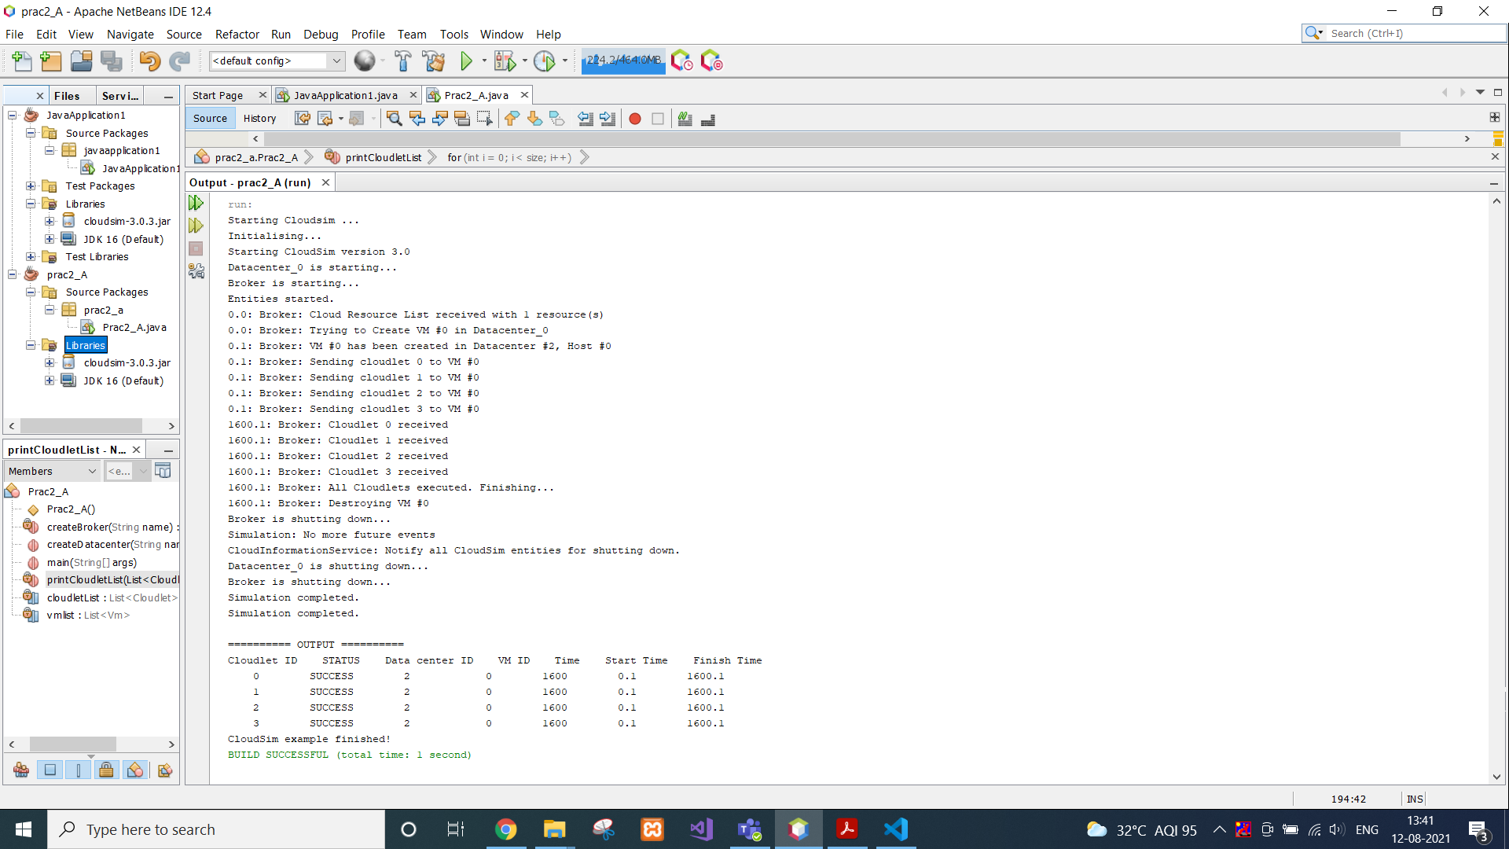

**For Second:**

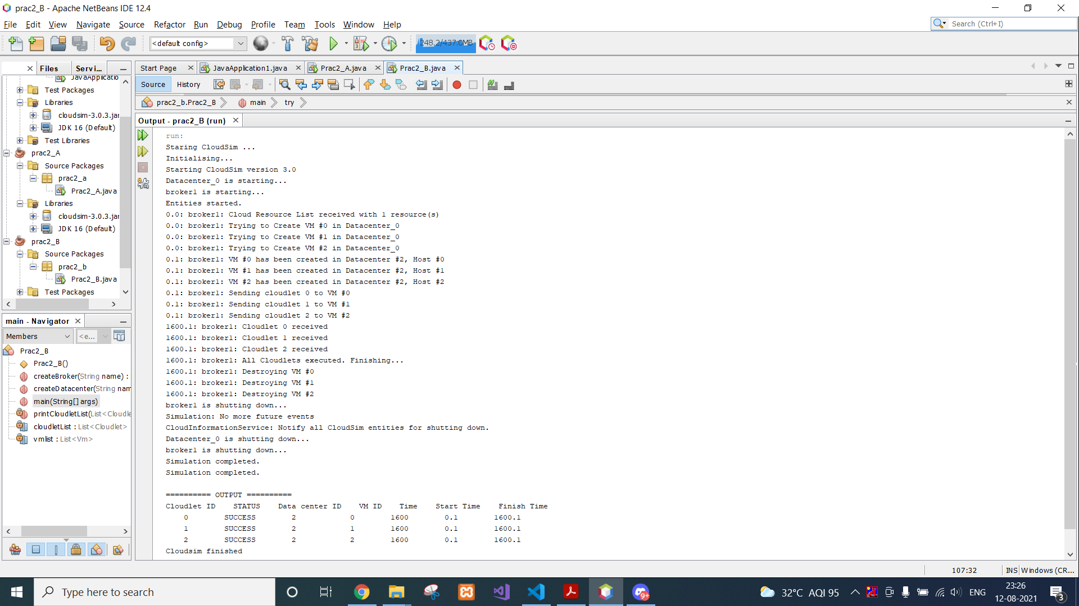

**CONCLUSION**

In this practical, we learnt about cloudsim architecture and implemented several different scenarios using different number of datacenters, hosts and cloudlets